# Fitness Membership Analytics Challenge: Optimize Retention, Revenue, and Engagement

In this challenge, you'll take on the role of a data analyst at MyGym, a fast-growing fitness center chain with multiple locations across California. MyGym offers a wide range of membership tiers, subscription models, and amenities, including group classes, personal training, and multi-location access. Gaining insights into how members engage with these services is crucial for optimizing operations and designing targeted, effective membership offers.

## Your Mission

Use this dataset to develop an analytical report or dashboard that helps MyGym:

* Understand which member segments bring the most value
* Identify areas for pricing, subscription, or service optimization
* Improve customer experience through data-driven insights
* Optimize staffing and facility allocation across locations
* Explore trends in retention, usage, and upgrade behavior

## Example Questions to Explore

These are exploration prompts, not a checklist. Feel free to go beyond them and uncover unexpected patterns.

* Which membership types are linked to the highest retention or revenue?
* Do pricing models (e.g., monthly vs. early bird annual) affect churn or satisfaction?
* Are some locations performing better than others in terms of engagement or profitability?
* How does personal training usage or group class participation influence value?
* What effect do discount types (promo, student, loyalty) have on final revenue?
* Do certain access types (off-peak, all hours, priority) impact visit frequency?
* What geographic patterns emerge from multi-location access behavior?
* How do different customer segments use the gym throughout the week?
* Can you identify clusters of high-value members or potential churn risks?

**Submission Guidelines**

* **Format:** Share your completed **dashboard or report** (any tool or format you prefer).
* **Creativity:** You are free to be as innovative as you wish — feel free to add your own metrics, visuals, and insights.
* **Deadline:** **20th August 2025**
* **Delivery:** Submit your work as a link (if online) or file (if offline) along with any brief note on methodology.
* This is the summary of the dashboard , you can get each facility relate with the revenue and how revenue generate by the given all the conditions.  
  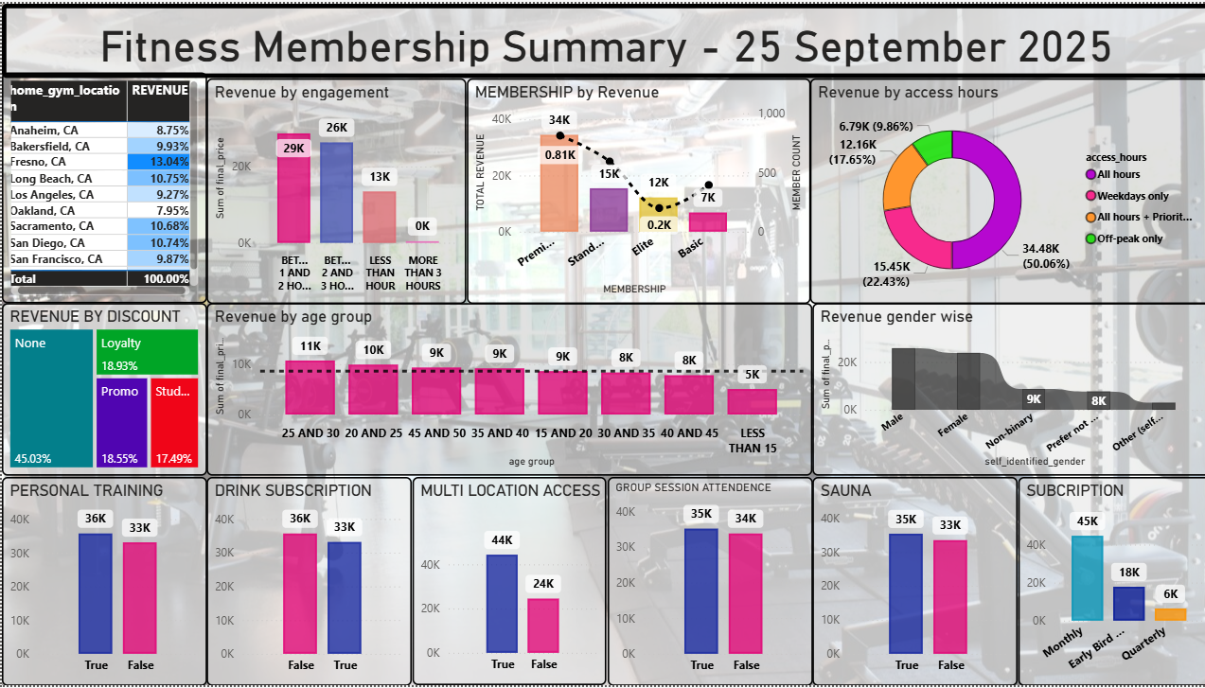
* Churn predicted by last visit day
  + More than 100, high risk
  + More than 75, low risk
  + Below 75, regular customer
* The dashboard below gives location wise comparison and all,
* Member health given regular customer relevant details
* Engagement is the visiting terms of the week and spending time

